
Narrogin Senior High School
English Learning Area

WRITTEN EXAMINATION ANSWER BOOKLET

NAME: __________________________________________________

TEACHER: _______________________________________________

ENGLISH
YEAR 10
2022

INSTRUCTIONS TO CANDIDATES

Write all responses in this booklet.

Write the number of the question next to the beginning of your answer.

All writing must be done in blue or black pen only.

Do not remove pages from this answer book. Extra pages may be added.

SECTION |  | COMMENT
WRITING | /50

Time allowed for this paper
Reading time before commencing work: 5 minutes
Working time for paper: One Lesson
Structure of this paper

Section | Number of questions available | Number of questions to be attempted | Suggested working time
Section One: Writing | 1 | 1 | One lesson

Instructions to candidates:

1. The rules for the conduct of Semester Examinations are set by the school. Sitting this assessment implies that you agree to abide by these rules.

2. Write your answers in the standard answer book provided.

3. Your responses should address the specific requirements of the questions asked and you should follow any specific instructions given.

4. During the reading time you may not write.

SECTION TWO: WRITING

Allow approximately 50 minutes to complete this section. (50 marks)

Compose an imaginative or persuasive text that uses language features and text structures in response to the image below.

- Language features: The features of language that support meaning (for example, sentence structure, noun group/phrase, vocabulary, punctuation, figurative language). Choices in language features and text structures together define a type of text and shape its meaning. These choices vary according to the purpose of a text, its subject matter, audience, and mode or medium of production.

- Text structures: The ways in which information is organised in different types of texts (for example, chapter headings, subheadings, tables of contents, indexes and glossaries, overviews, introductory and concluding paragraphs, sequencing, topic sentences, taxonomies, cause and effect). Choices in text structures and language features together define a text type and shape its meaning.

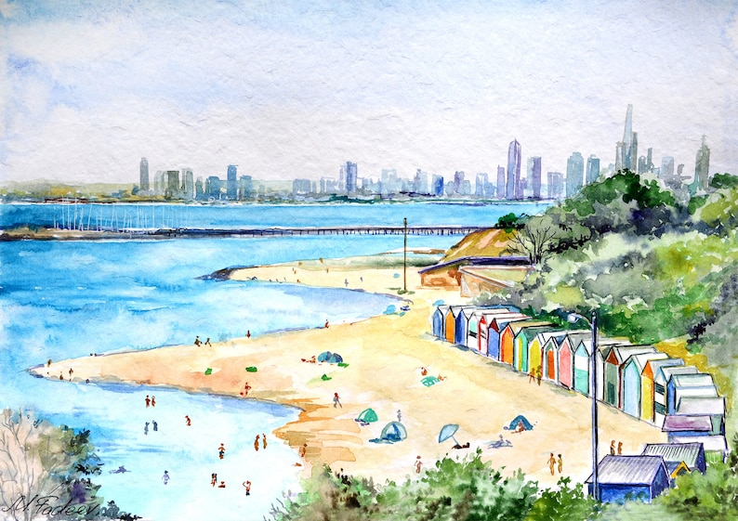

- Plan your story.
Mapping/brainstorm

- Write your story.

END OF SECTION TWO

